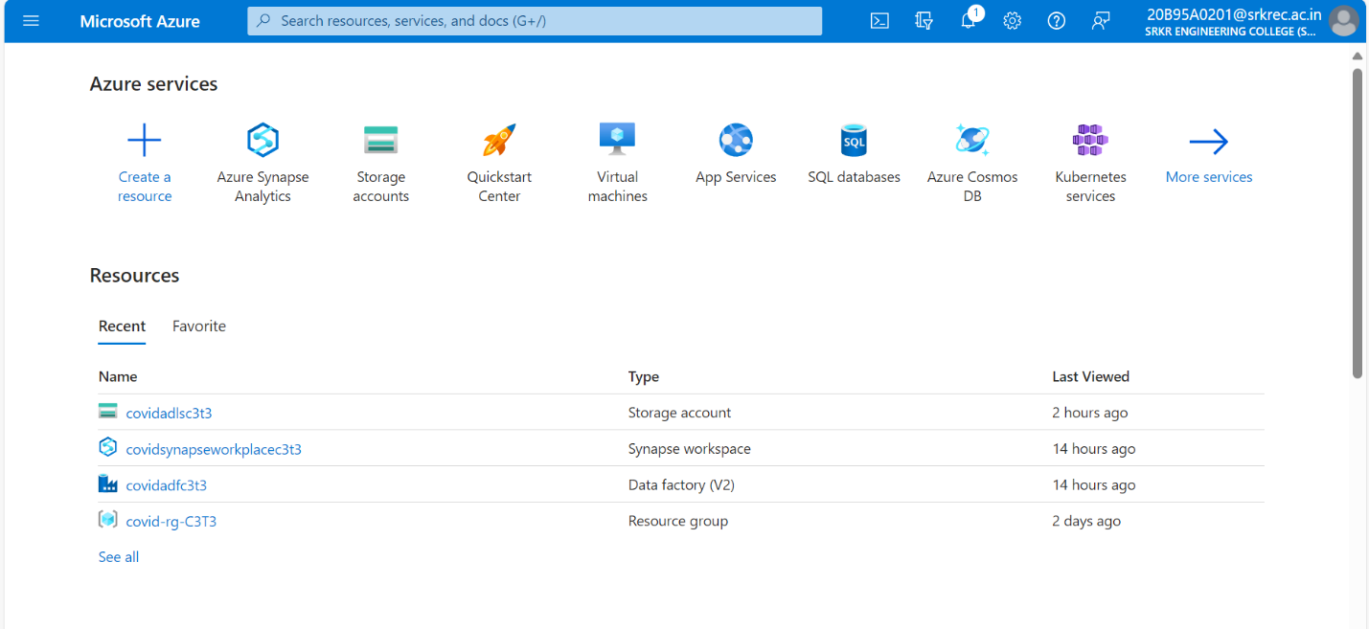

Step 1: Created one Resource group and required resources for project like Storage account, Synapse workspace(data warehouse), Azure Data factory.

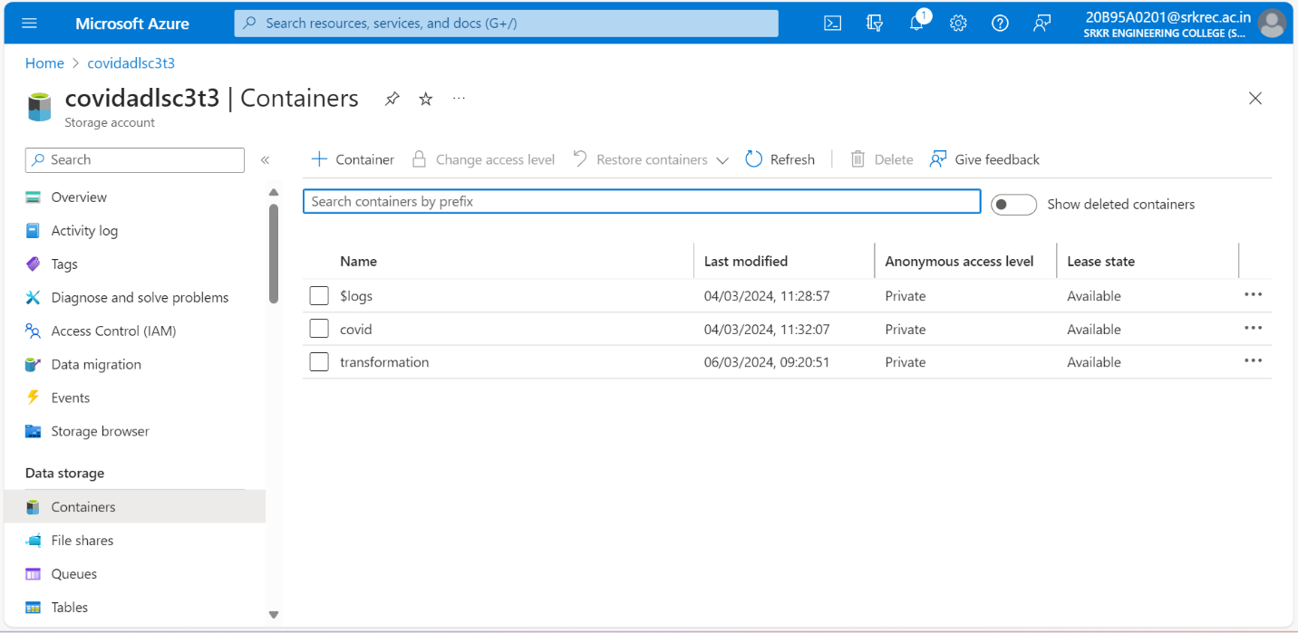

Step 2: Created Container with name “**covid**” in Storage account (data lake) for holding folder which contains flat files.

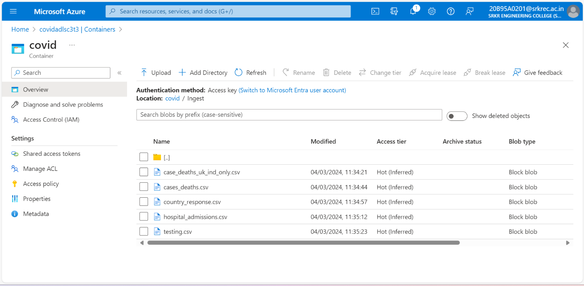

Step 3: Create Folder with name “**Ingest**” inside the Container “covid” and uploaded csv files (data sets) form personal computer which are there in zip file given in project document .

Step 4: Create **Azure synapse resource** and one **dedicated pool** inside the azure synapse for data warehouse creation and it should be turn on.

Step 5: Creating **two linked services** as per the project requirement in Azure data factory.

* **Storage account (data lake) to Azure data factory.**
* **Azure synapse workspace to Azure Data factory**.

Step 6: Created **dataset (DS_adlsV2Dataset)** for fetching flat files from storage account (data lake) which are present in ingest folder inside covid container.

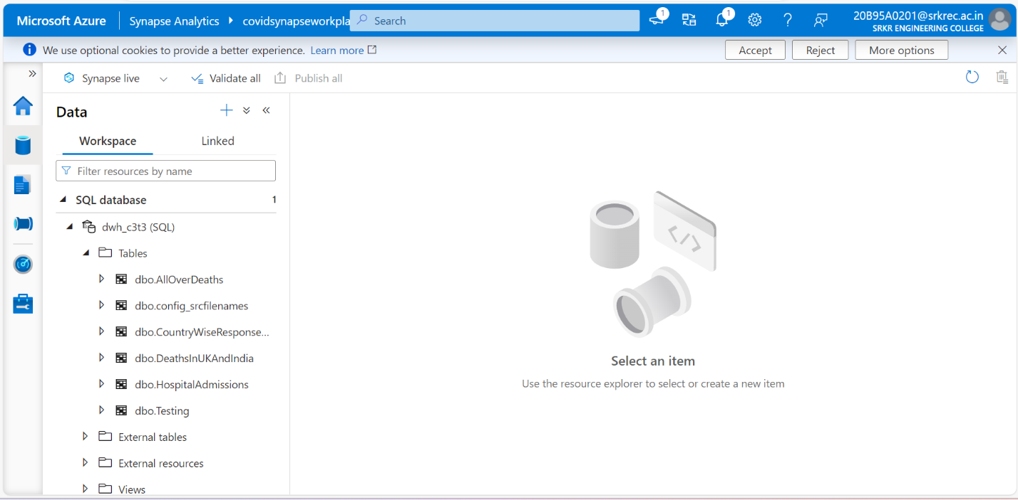

Step 7: Created requried **SQL Tables** in synapse SQL database by writing create table queries in Synapse workspace (SQL Script).

Step 8: Created **dataset (DS_dwdataset)** for inserting into SQL Tables created in synapse(data warehouse).

Step 9: Created **stored procedure(sp_GetConfigSrcFileNames)** for fetching records from parameters table.

Step 10: Created **dataset(DS_configDataset)** for fetching parameters table form synapse(data warehouse).

Step 11: Creating required datasets in Azure data factory

* To fetch covid flat files from Storage account (data lake) **🡪(DS_adlsV2Dataset).**
* To fetch parameters table from Synapse (data warehouse) **🡪(DS_configDataset).**
* To insert data into SQL tables in Synapse (data warehouse) **🡪(DS_dw_dataset).**
* To fetch cases_deaths.csv file from storage account (data lake) **🡪(DS_casesanddeaths_target).**
* To insert data transformation done file by using dataflow into storage account (data lake)**🡪(DS_max_daily_deaths_target)**

Step 12: Before creating pipeline in data factory, we need **to turn on the dedicated pool**. we need to check this two to three times while moving on to creation of pipeline.

Step 13: Drag and Drop the **Look up Activity** into pipeline workspace and set the **source dataset** **(DS_configDataset)** for Lookup and choose the option **stored procedure** andgiven the stored procedure name created in synapse (data ware house).

Step 14: Drag and Drop **For each activity** in pipeline workspace and configure the for each activity settings like **Items** with output of look up activity **(@activity(‘Lookup1’). Output.value).**

Step 15: Click on add activity symbol present on foreach activity and inside foreach activity add a **Copy activity** for copy data from CVS file into SQL table.

Configure settings at source side in copy activity by giving dataset **(DS_adlsV2Dataset)** and giving folder name and file name dynamic by taking from foreach activity by **item .**

Folder Name **(@ {item (). FolderName})**

File Name **(@ {item (). FileName})**

Step 16: Configure setting in copy activity at sink side by giving dataset **(DS_dwdataset)** and giving sqltableName dynamically by taking from foreach activity by item🡪sqltableName **(@ {item (). sqltableName})**

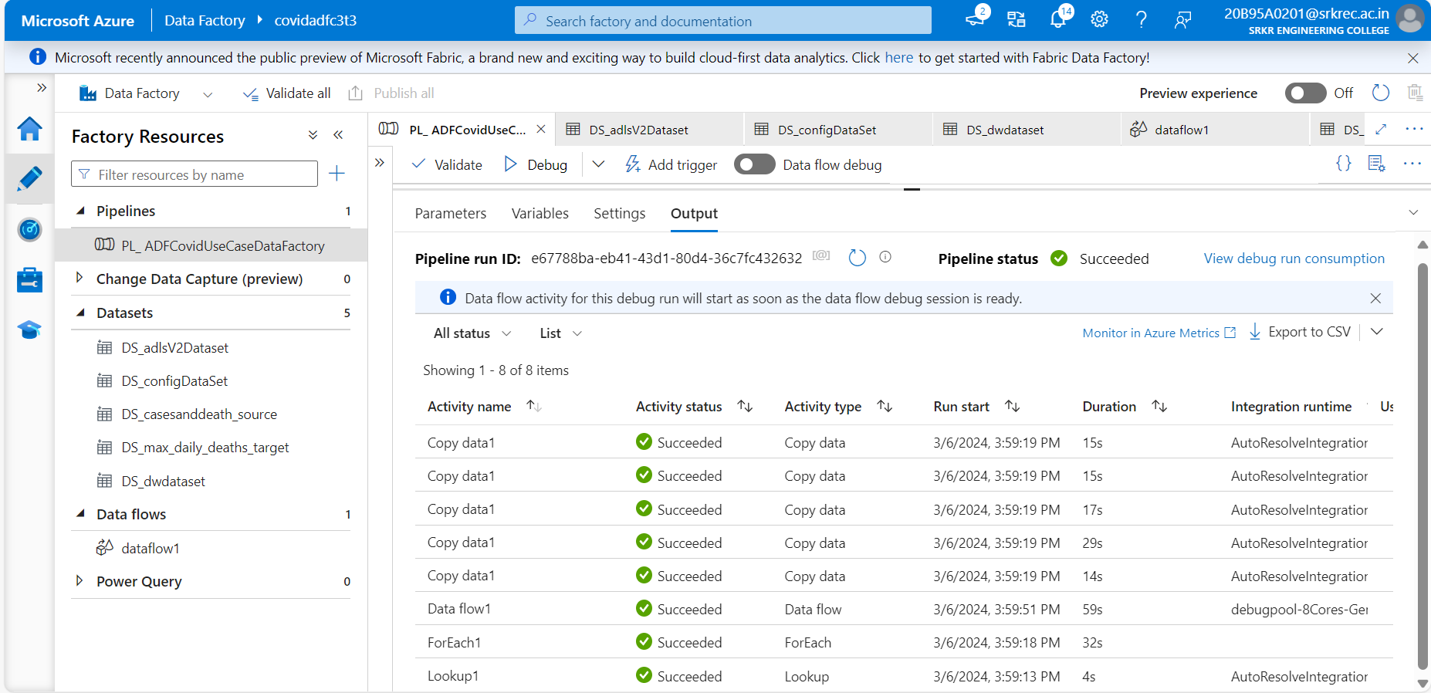

Step 17: After setting whole pipeline by using Lookup and Foreach activity recheck all parameters given in each configuration setting, check the dedicated pool is turn on and then turn on the debug option in pipeline. Finally all the activities are successfully ruined.

Step 18: After successfully run of pipeline now we need check the data inserted into tables in data warehouse by preforming two SQL queries operation given in project documentation.

Step 19: After run first SQL Query written in SQL script and it is successfully ruined and given output as per the query.

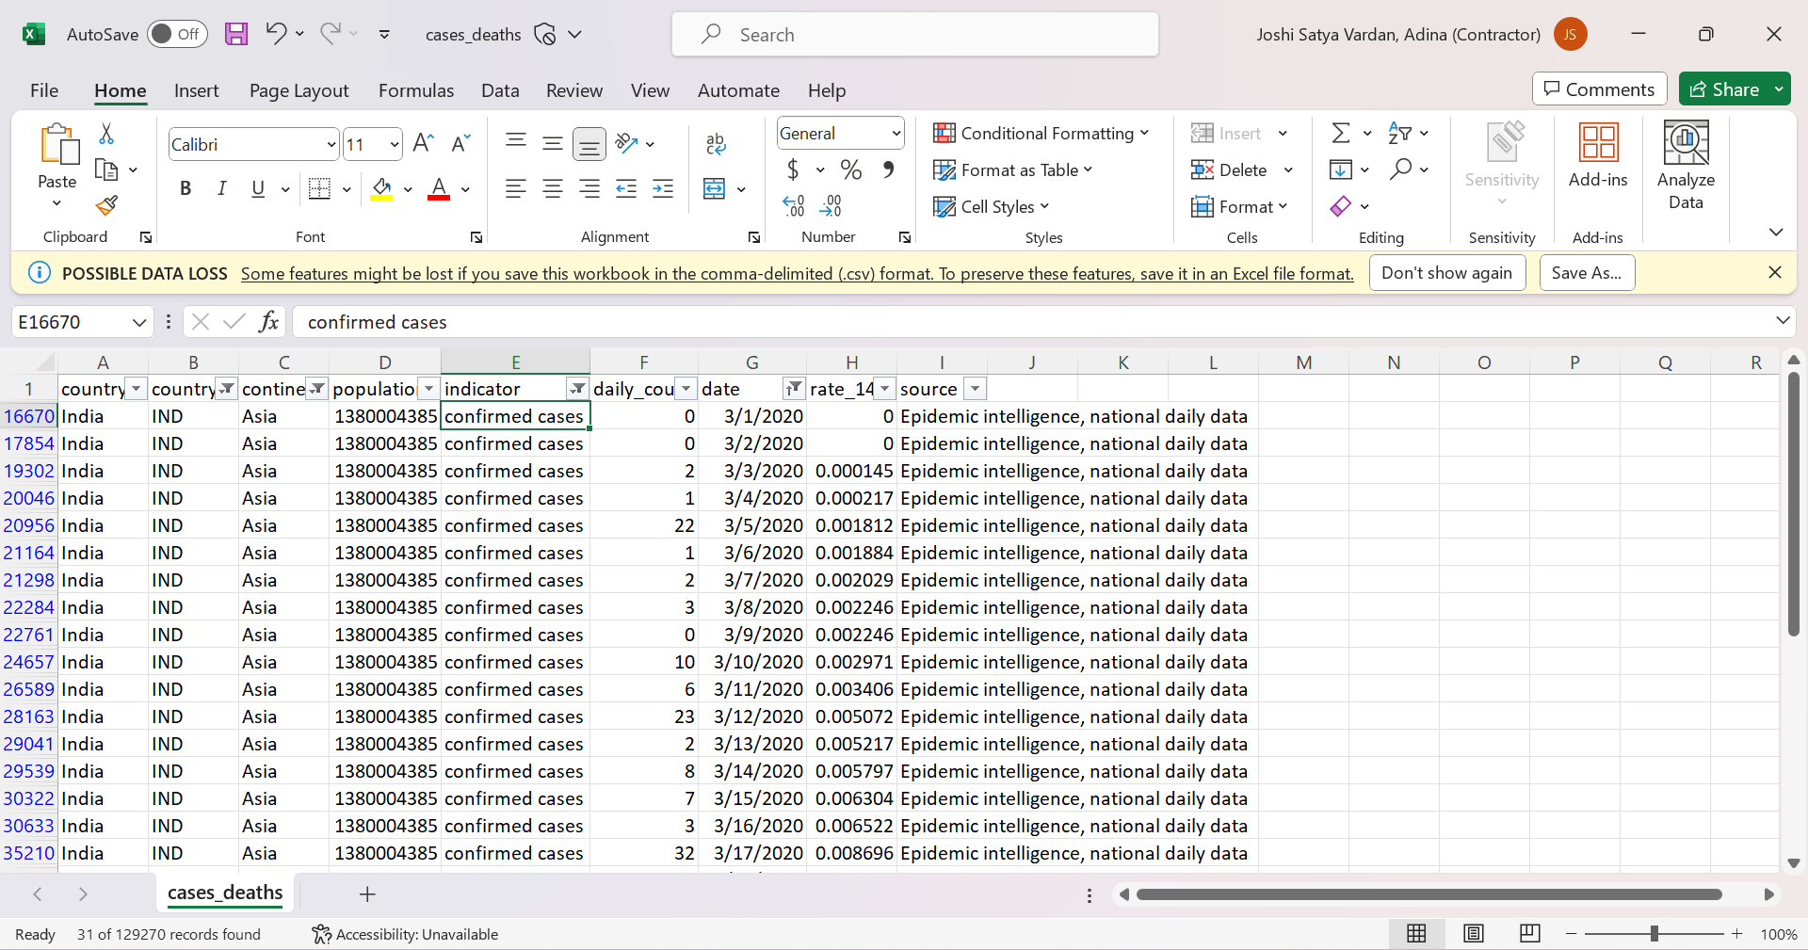Step 20: compare the output appear for previous SQL query written in SQL script with original CSV file in excel sheet.

Step 21: Wrote the second SQL Query as per the question given in the project documentation and click on run.

Step 22: Successfully query is ruined and given output as per the query.

Step 23: Compare the above SQL query output with data which is appear from CSV file which is open in excel for reference check.

Step 24: Create another container with name **“transformation”** for second requirement given in project for storing transformed data file by using data flow.

Step 25: Create source dataset (**DS_casesanddeath_source**) for dataflow by giving a file specific filename on which data transformation need to be taken place as per project requirement.

Step 26: Create target dataset (**DS_max_daily_deaths_target**) for dataflow to keep that data transformed file in specific place for further use.

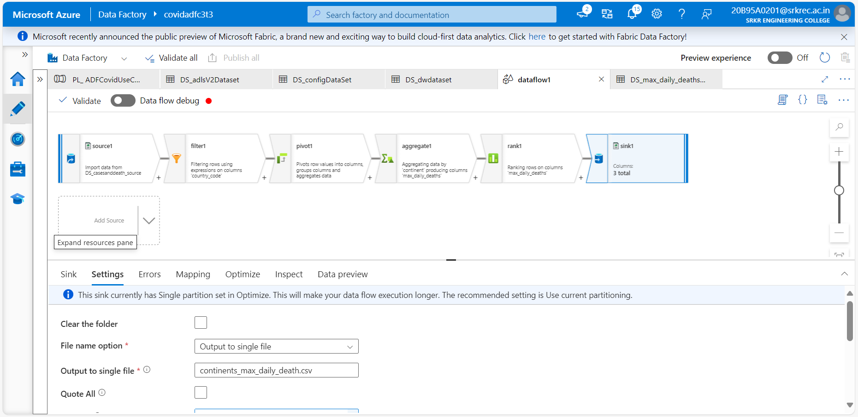

Step 27: Develop dataflow by using some transformations like source, filter, pivot, aggregate, rank and sink as per the question given in project documentation.

Step 28: After successfully creating dataflow I click on dataflow debug output appear as per the question .

Step 29: Drag and Drop the data flow into the pipeline workspace and connect with before activity to run after successfully complication of before activity.

Step 30: Dataflow is ruined successfully after click on debug as how in above picture.

Step31: After that we need to check file is appear in the transformation container in storage account (data lake).I successfully got that file in my container as per the question given in the project documentation.

